Bubbo Bubbo – bug tracking

1. When alt-tabbing or clicking something on a second monitor, the trajectory for where the bubbles should be shot seizes to work. / As shown in the screenshot below /

**Steps to reproduce:**- Start new game  
- Begin playing  
- Alt-Tab or click anywhere on second monitor

**Severity: High**

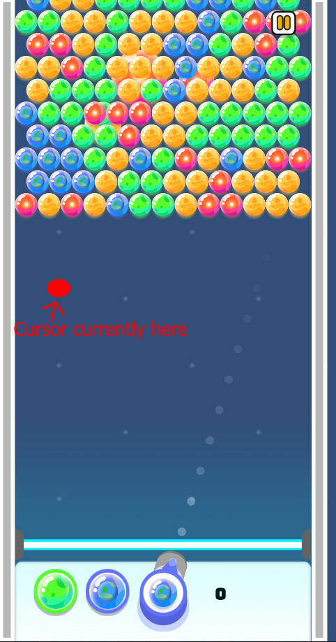

1. The “Pause” button doesn’t appear to work properly, making you have to click at least twice on it before it leads you to the “Game paused” screen.

**Steps to reproduce:**- Start new game  
- Click on pause

**Severity: Medium**

1. It isn’t made clear on what principle the game works; shooting a bubble with a different colored bubble sometimes “destroys” most of, if not all of the current bubbles on screen. Sometimes upon destroying all of the current bubbles, the game no longer allows you to shoot more bubbles

When the player shoot bubbles, sometimes the player can destroy other bubbles which aren’t the color bubble the player has shot.

**Steps to reproduce:**

* Start a new game
* Shoot bubbles into different colored bubbles

Also, it appears that the principle on which the amount of bubbles are destroyed is random. Sometimes it destroys 4-5, sometimes it destroys 40-50. Might need to check with the developers regarding this.

**Severity: Medium**

1. When playing for 5-10 minutes, or starting a new game, the app decides to mute the sound. In the “Game Paused” menu, the sound is on. If you mute it and unmute it, the issue persists. When in the main menu, the “mute/unmute” button doesn’t appear to work as well.

**Steps to reproduce:**

* Start the game
* Start playing or quit and start a new game

**Severity: Medium**

1. At times, when ricocheting the bubble you shoot, the game freezes and the player cannot continue onwards with it, they will have to leave the current game and start another. This appears to mainly happen when ricocheting off the left wall. / As shown in the screenshot below /

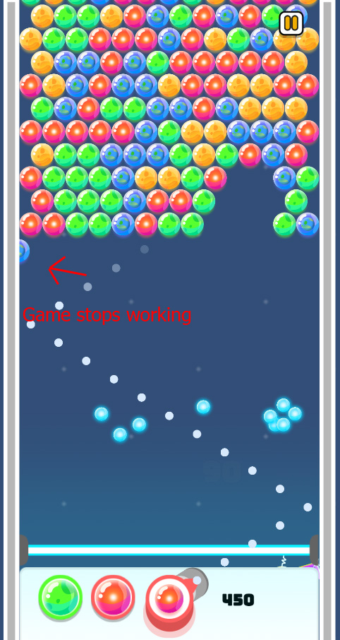

**Steps to reproduce:**

* Start a new game
* ricochet in different places

**Severity: High**

This appears to also happen after the ricocheting, when the bubble touches another bubble / As shown in the screenshot below /

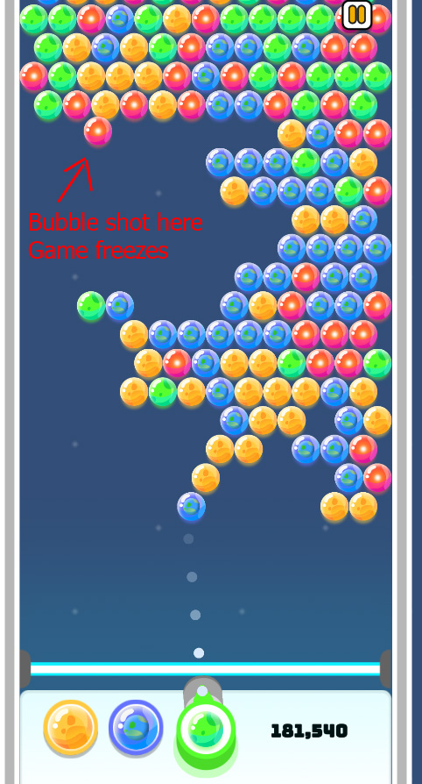

**Steps to reproduce:**

* Start a new game
* ricochet in different places

**Severity: High**

1. Even without ricocheting, the game freezes / As shown in the screenshot below /

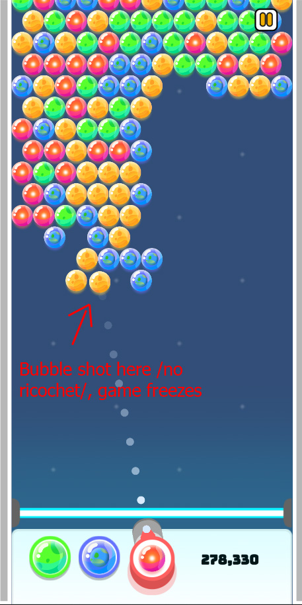

**Steps to reproduce:**

* Start a new game
* Shoot bubbles

**Severity: High**

1. Most of the observed special bubbles do not appear to have any effect in the game.

**Steps to reproduce:**

* Start a new game
* Shoot at the special bubbles

**Severity: Medium**

1. When starting a new game, it states “Move mouse to aim, left click to shoot!”. It appears that shooting can be done with both the left and right clicks of the mouse.

**Steps to reproduce:**

* Start new game
* Use right click to shoot

**Severity: Low**